Database View and Top 5 Queries

**Query 1** How many patients are paying out-of-pocket vs how many have insurance?

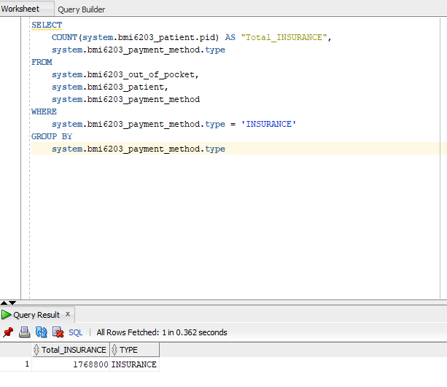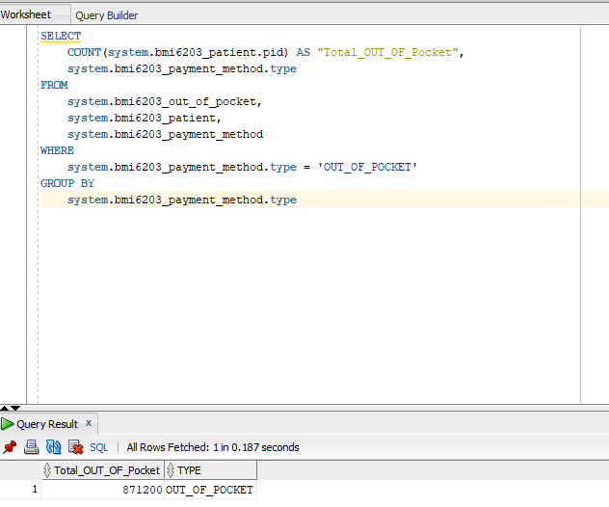

**Query 2** How many plates were run on a specified date?

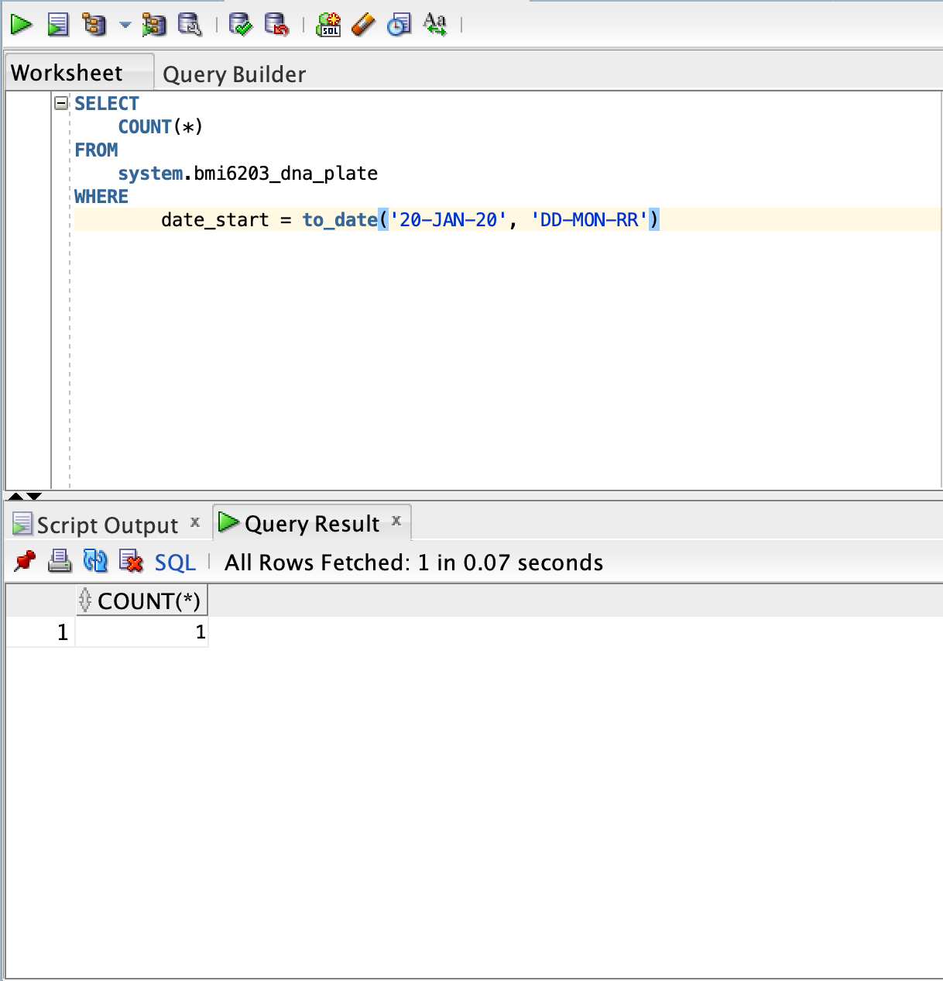

**Query 3** Number of patients from a specified state?

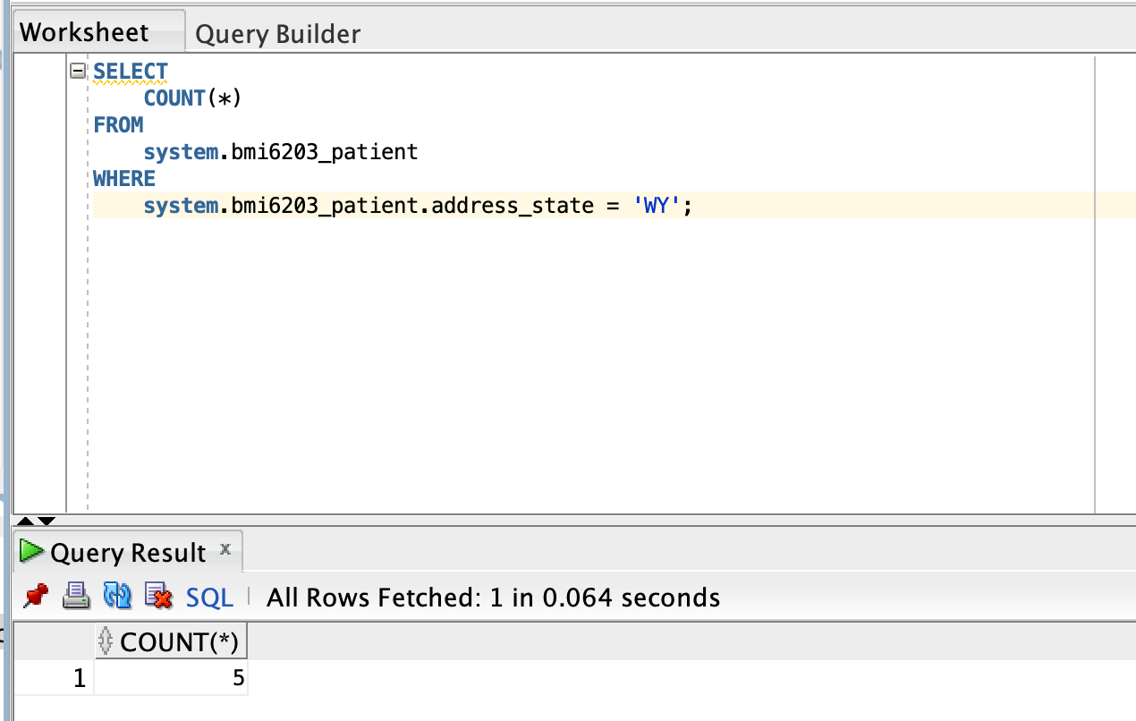

Distribution of patients from every state?

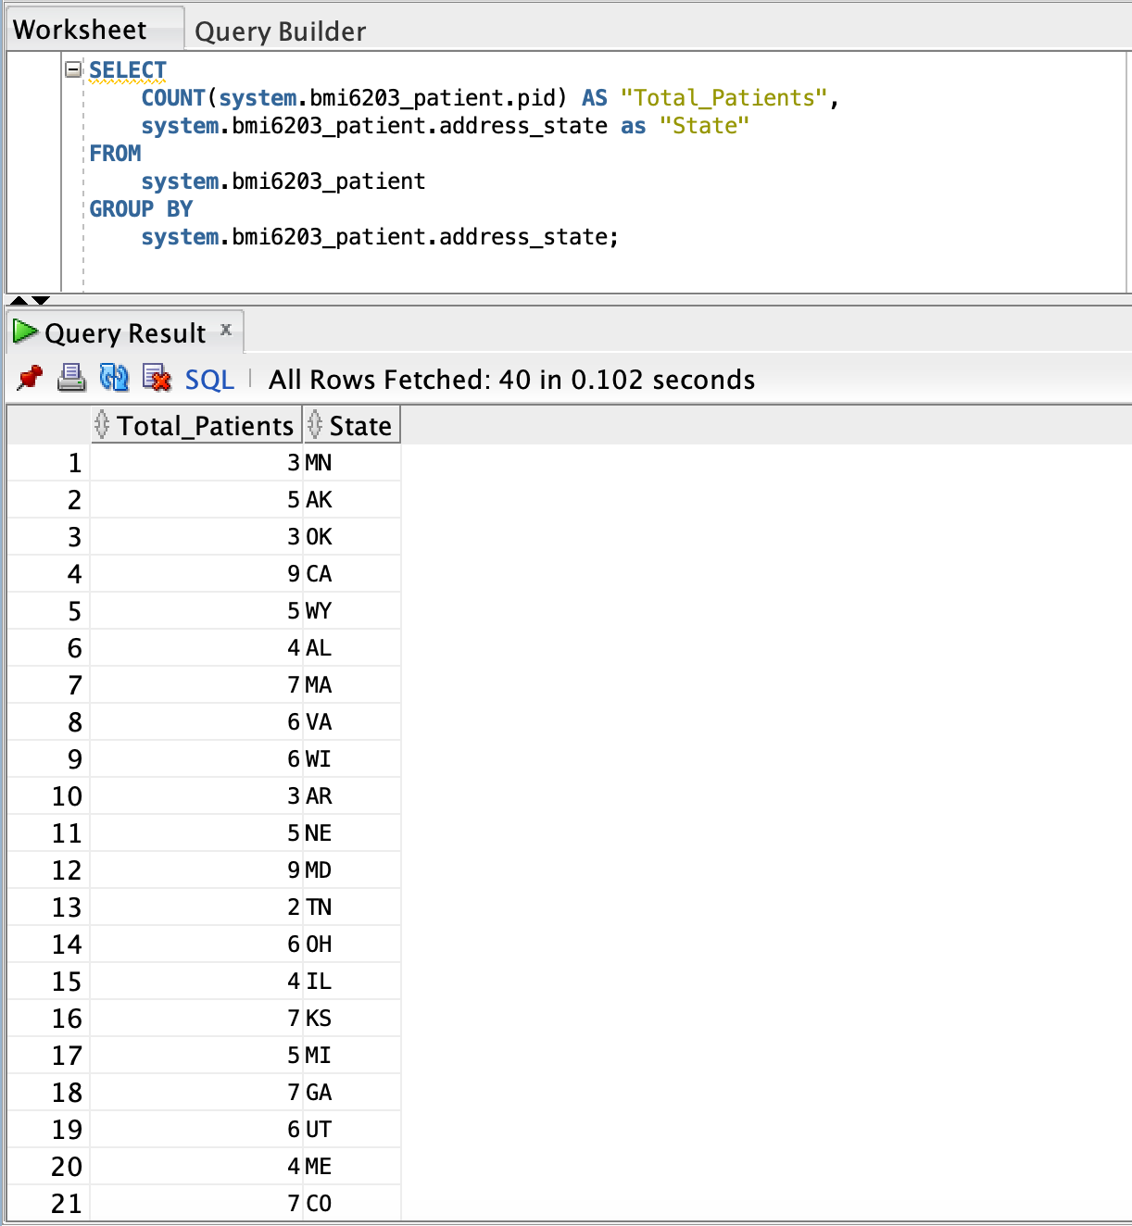

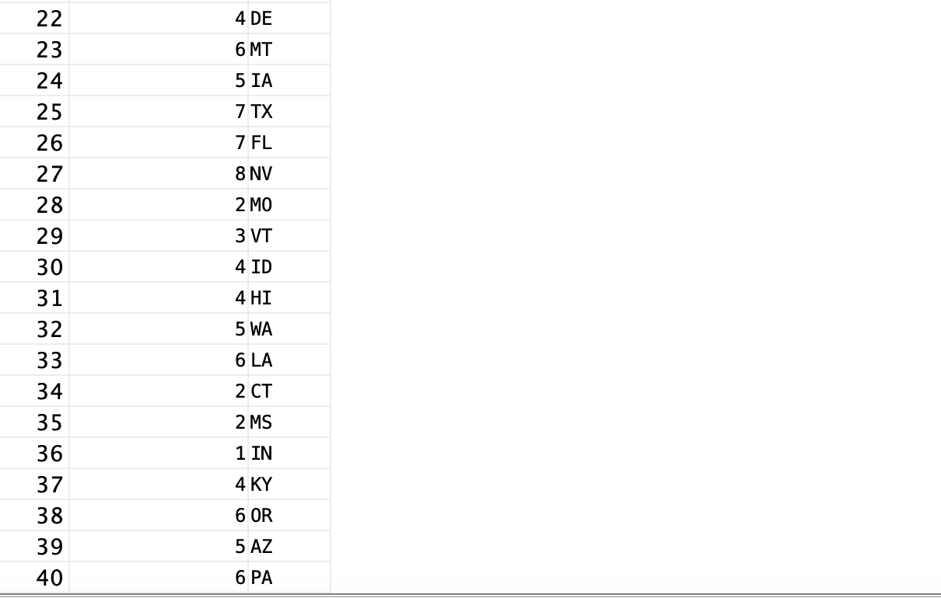

**Query 4** Which instruments were run per individual per specified date?

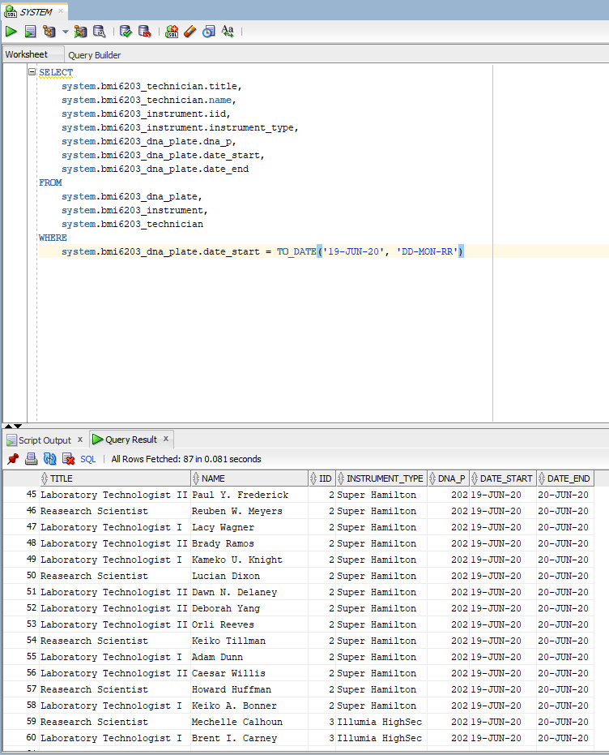

**Query 5** Which provider(s) received the most reports?

